*Calculator Snooker*

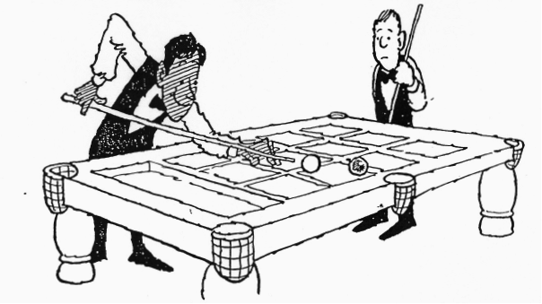*A Game for 2 players*

Player A enters any *two-digit* number. B takes a shot by performing a multiplication sum. To pot a ball, the first digit on the answer must be the same as the value of a ball.

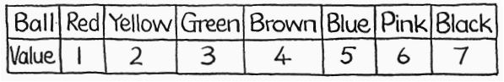

Otherwise, the rules are similar to real Snooker. There are 10 (or 15) reds and one of each of the six colours. A player must score in the order red, colour, red, colour, and so on, until all the reds have gone. (Note that the colours are replaced but the reds *are not)*

When the last red has gone, the colours are potted in order and are not replaced.